Approach for combining kind + containerlab

1. Introduction
Modern private cloud environments require both:
- Application orchestration (handled by Kubernetes)
- Realistic network infrastructure simulation (handled by Containerlab)
While KIND simulates Kubernetes clusters, it lacks infrastructure-level networking. Containerlab complements this by emulating data center networking components such as ToR and spine switches.
Combining both enables a full-stack private cloud simulation, including:
- Compute layer (pods, nodes)
- Network layer (ToR, spine, routing)

2. Architecture Overview
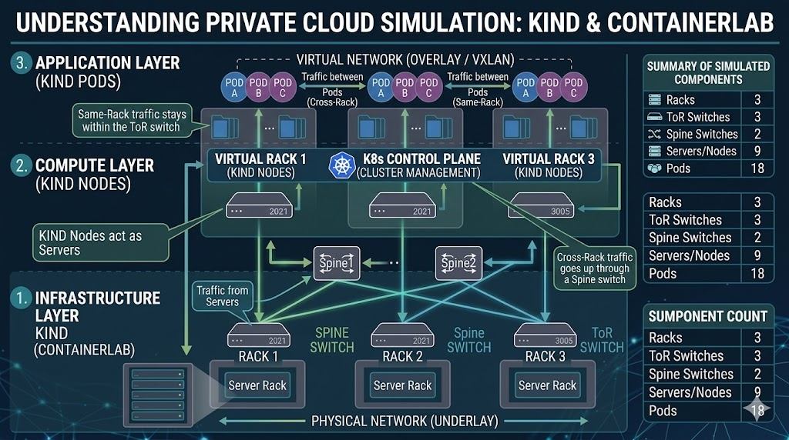
2.1 Target Design
- 3 Racks
- Each rack:
  - 1 ToR switch
  - 3 servers (nodes)
- Each server:
  - 2 pods
Total Components
Component | Count
Racks | 3
ToR switches | 3
Spine switches | 2
Servers (nodes) | 9
Pods | 18

3. Layered Architecture
3.1 Infrastructure Layer (Containerlab)
Simulates:
- Spine switches
- ToR switches
- Physical links

3.2 Compute Layer (KIND)
Simulates:
- Kubernetes cluster
- Nodes (servers)
- Pods (applications/VMs)

3.3 Integration Layer
- KIND nodes are connected to ToR switches
- Each node behaves as a physical server within a rack

4. Detailed Network Design
4.1 Underlay Network (Containerlab)
Spine Layer
Spine1 → 10.0.0.1/24
Spine2 → 10.0.0.2/24
ToR Layer
Rack | ToR | Subnet
Rack1 | ToR1 | 10.0.1.0/24
Rack2 | ToR2 | 10.0.2.0/24
Rack3 | ToR3 | 10.0.3.0/24

4.2 Server (Node) Addressing
Rack 1
Node1 → 10.0.1.10
Node2 → 10.0.1.11
Node3 → 10.0.1.12
Rack 2
Node4 → 10.0.2.10
Node5 → 10.0.2.11
Node6 → 10.0.2.12
Rack 3
Node7 → 10.0.3.10
Node8 → 10.0.3.11
Node9 → 10.0.3.12

4.3 Pod Network (Overlay)
Node1 → 192.168.1.0/24
Node2 → 192.168.2.0/24
Each node runs:
2 Pods per node

5. Communication Flow
5.1 Same Rack
Pod → Node → ToR → Node → Pod
5.2 Cross Rack
Pod → Node → ToR → Spine → ToR → Node → Pod

6. Implementation Approach
- Create Containerlab topology (Spine + ToR)
- Create KIND cluster (9 nodes)
- Connect nodes to ToR switches
- Deploy 2 pods per node
- Configure routing

7. Metrics and Observability (Digital Twin Focus)
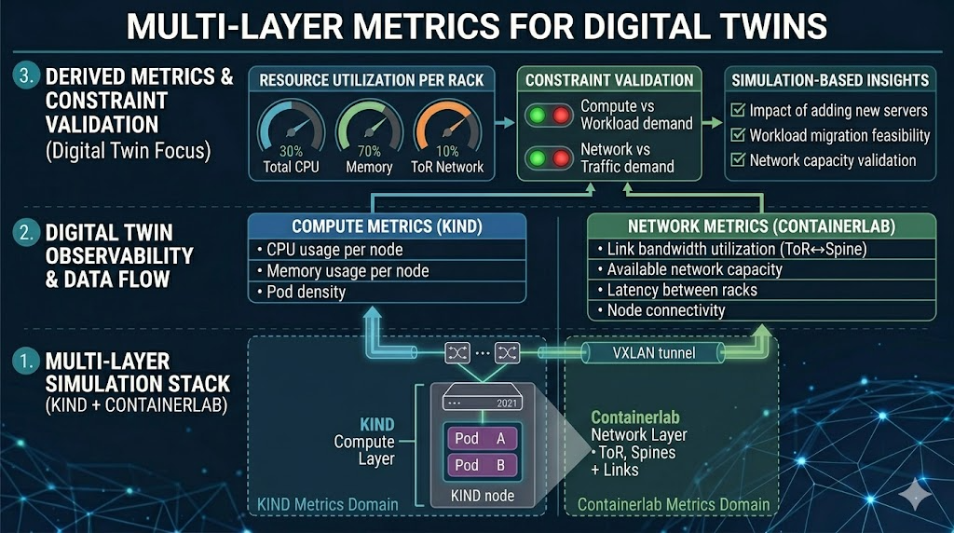
7.1 Compute Metrics (from KIND)
- CPU usage per node
- Memory usage per node
- Pod density per node

7.2 Network Metrics (from Containerlab)
Focus on high-level capacity metrics:
- Link bandwidth utilization (ToR ↔ Spine)
- Available network capacity
- Number of connected nodes per ToR
- Connectivity between nodes

7.3 Network Performance Metrics
- Latency between racks (optional)
- Throughput

8. Derived Metrics (Digital Twin Layer)
Derived metrics combine compute and network data to support simulation and decision-making.
8.1 Resource Utilization per Rack
- Total CPU usage of nodes in a rack
- Total memory consumption
- Network load on ToR switch

8.2 Constraint Validation
- Compute capacity vs workload demand
- Network capacity vs traffic demand
- Rack-level saturation

8.3 Simulation-Based Insights
- Impact of adding new servers
- Workload migration feasibility
- Network capacity validation before deployment

9. Benefits of Combining KIND + Containerlab
- Full-stack simulation of compute and network layers
- Realistic data center topology
- Enables constraint-based “what-if” simulations
- Supports digital twin modeling
- Cost-effective and reproducible

10. Challenges
- Resource limitations on local systems
- Integration complexity
- Multi-layer debugging

11. Conclusion
Combining KIND and Containerlab provides a comprehensive approach to simulating private cloud environments by integrating Kubernetes-based workload orchestration with realistic network topology emulation. By focusing on high-level compute and network capacity metrics, this approach supports effective digital twin modeling, enabling validation, planning, and optimization of infrastructure changes.

